Steps to create Virtual Machine:

* Click on create a resource and select Compute:

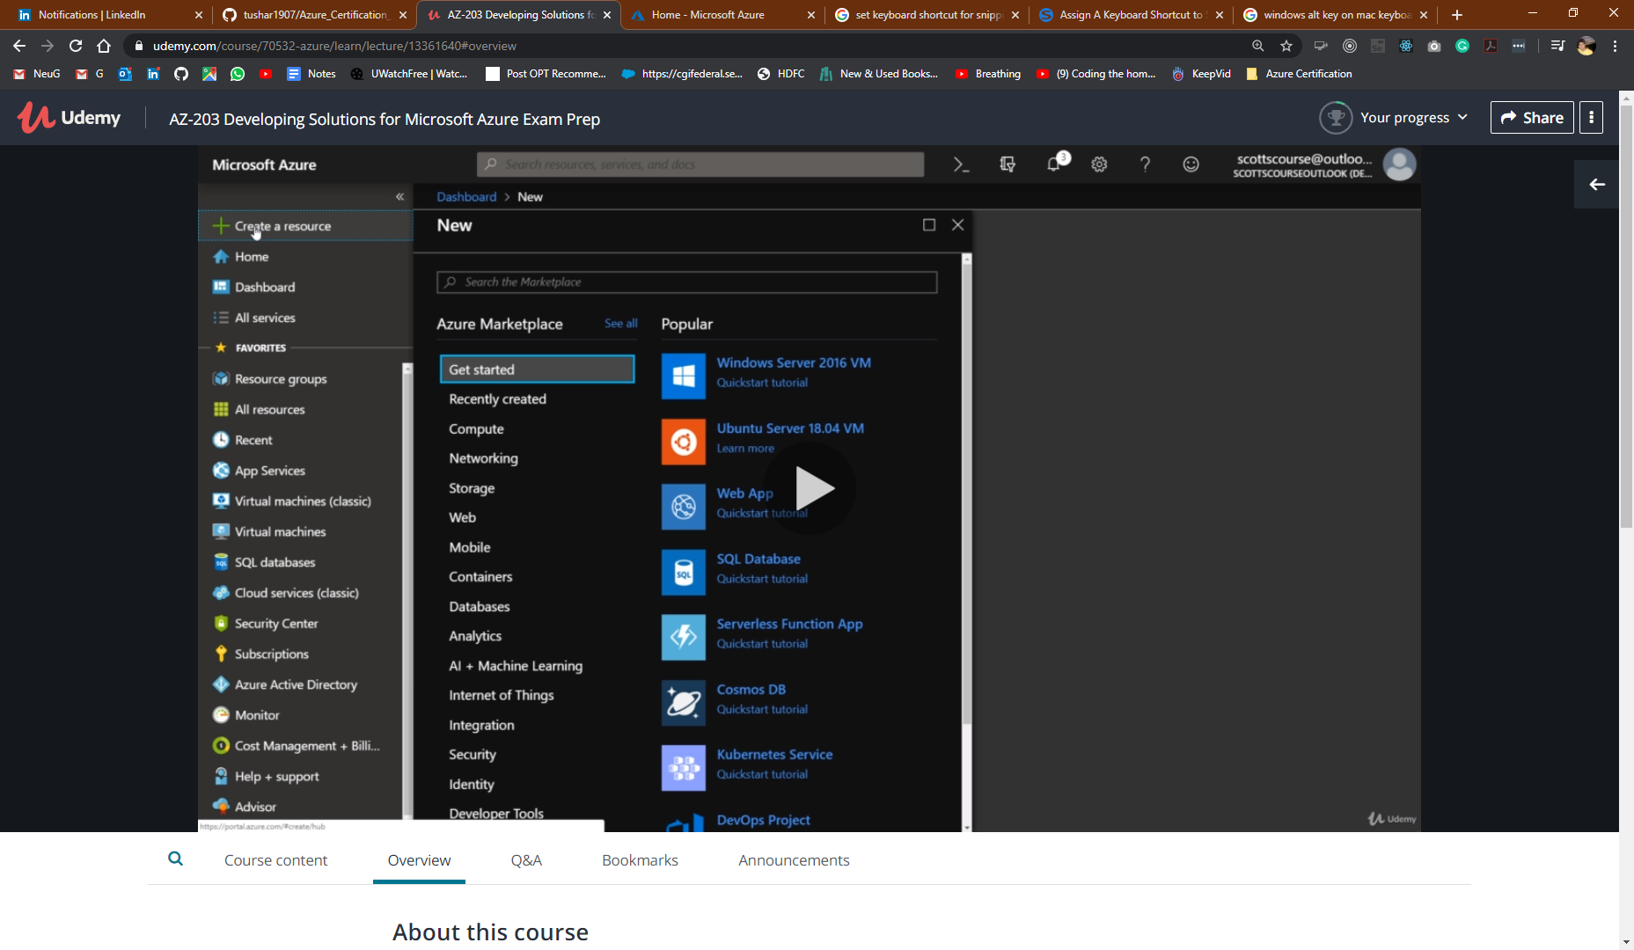

* Select windows data server 2000.

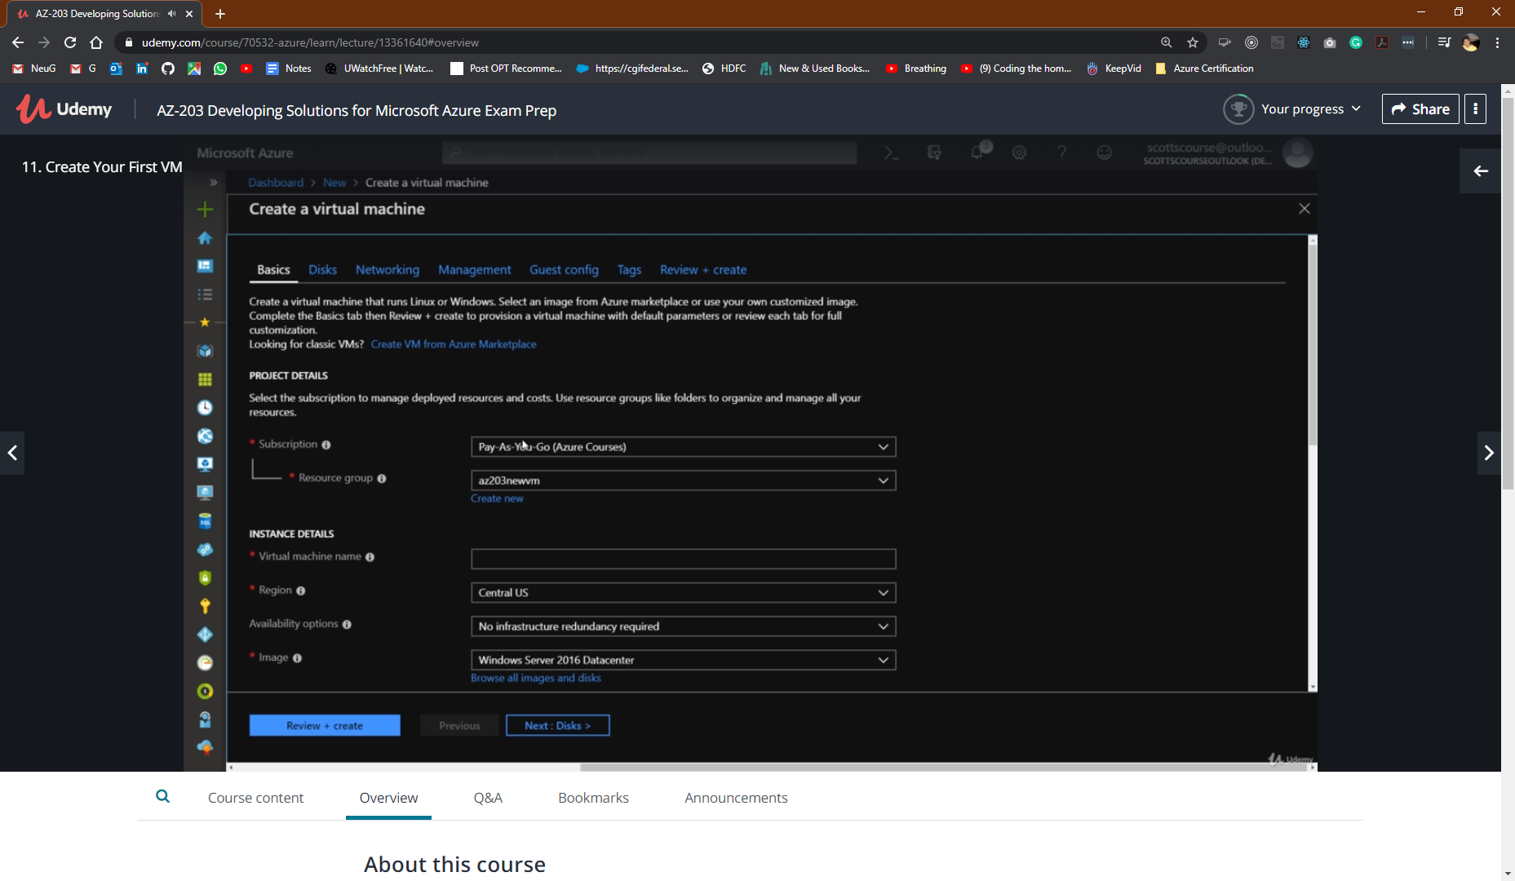

* Select a folder structure for resource group
* Select a unique name for virtual machine.
* Change the size if the given one is not required.

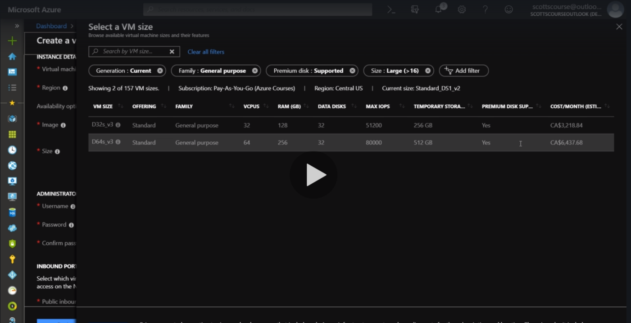

* Going to use the most basic one

